**Q1: Calculate** **the time for each process, define the priority?**

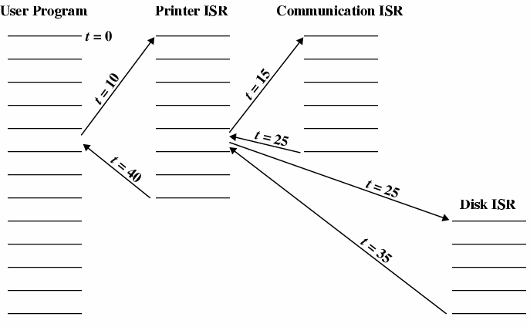

**Answer:-**

**The time for each process is:**

**1- Time For User program t=10**

**2- Time For Printer ISR t=10**

**3- Time For Communication ISR t=10**

**4- Time For Disk ISR t=10**